## Part One: Installation operation of GUI

**Step 1 :** decompress the compressed package "dist", as shown in Figure 1. Please note that the unzipped path cannot appear in Chinese. After decompression, the folder "dist" will appear, as shown in Figure 2.

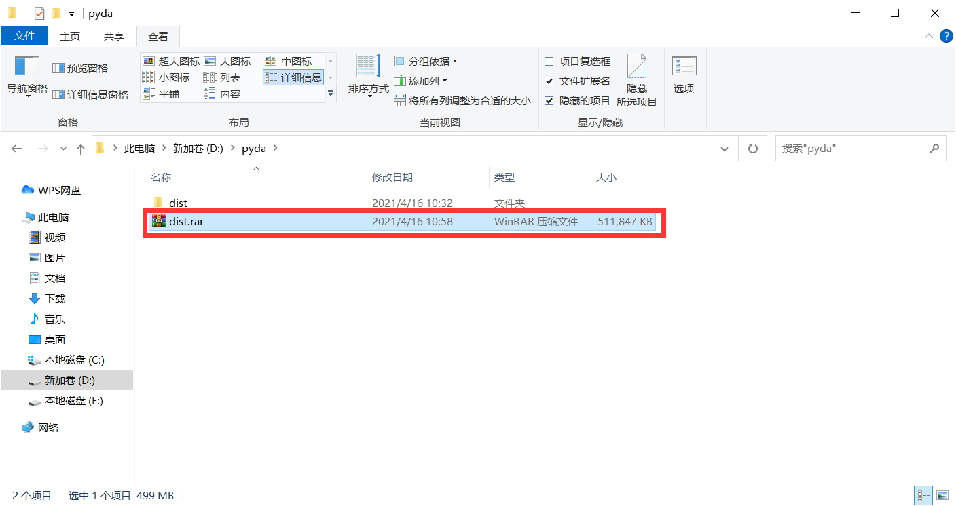

Figure 1: The compressed package "dist"

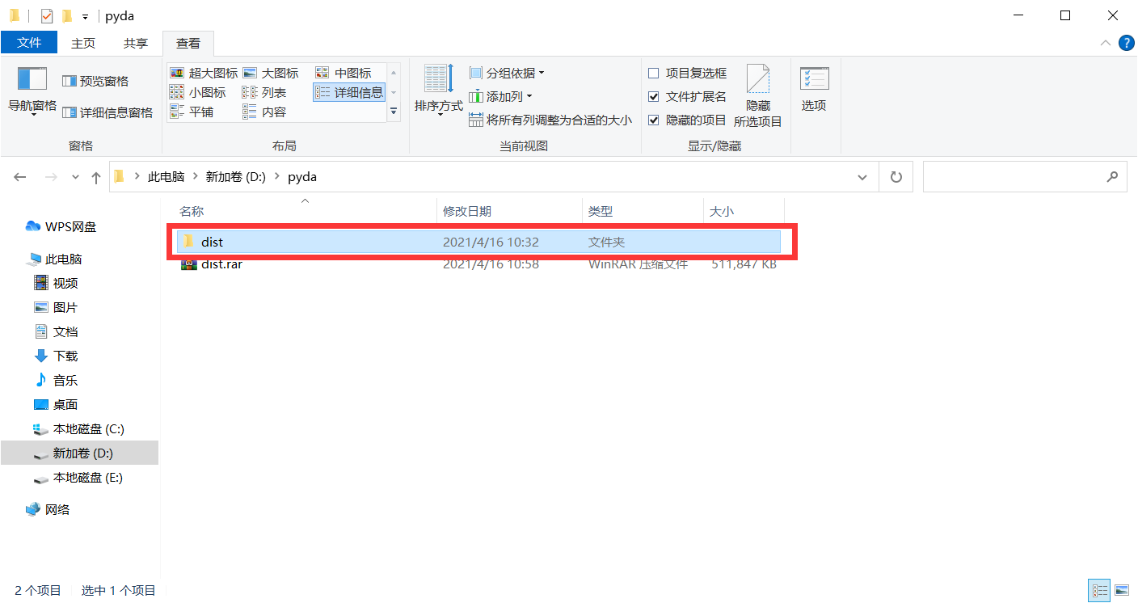

Figure 2: The folder "dist"

**Step 2 :** open the folder "static" and find it, as shown in Figure 3. Then double-click to enter the folder and find the file named "hanlp.properties", as shown in Figure 4.

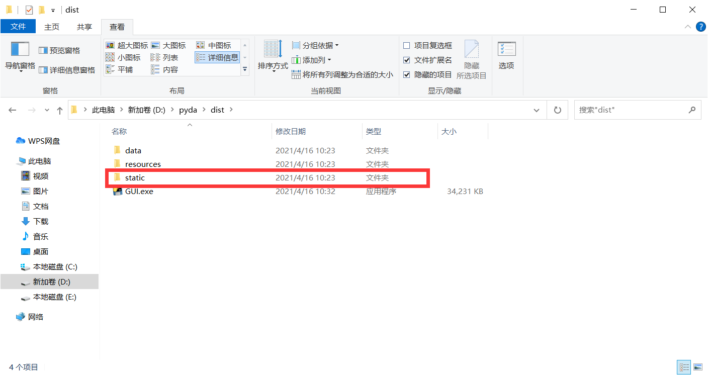

Figure 3: The folder "static"

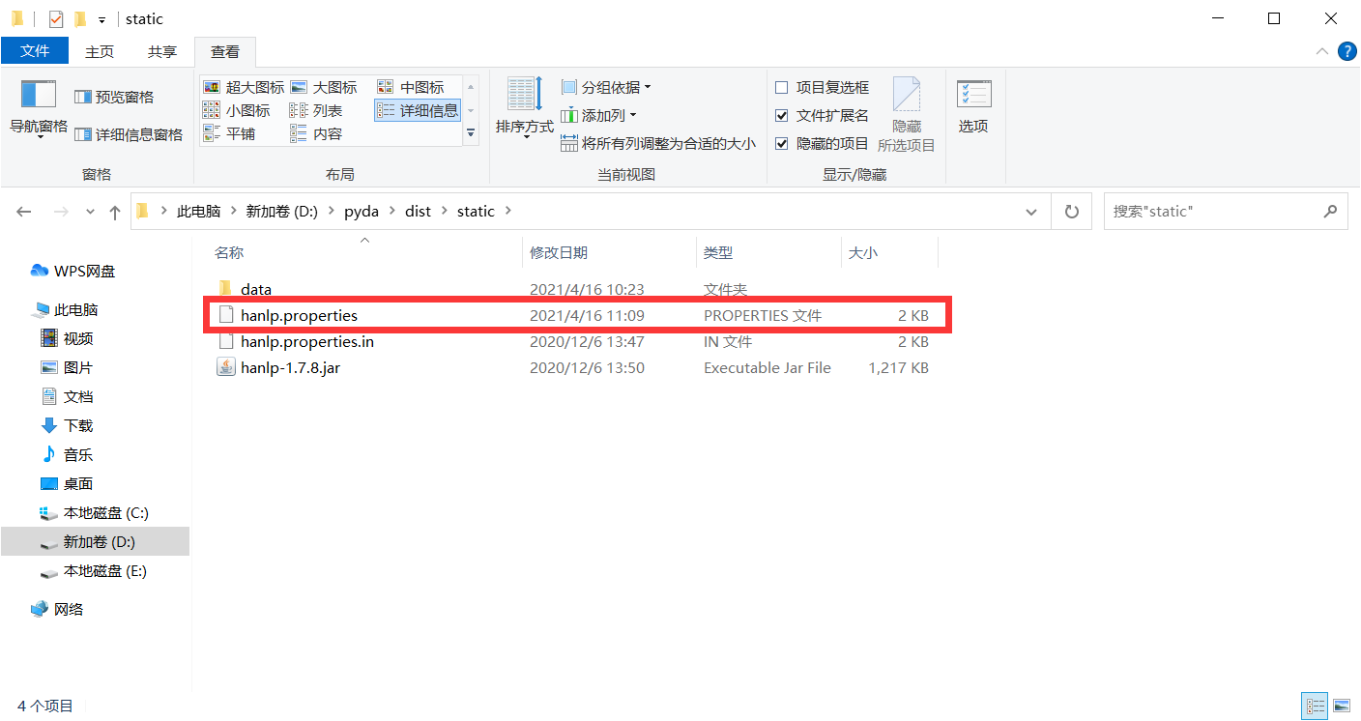

Figure 4: The file "hanlp.properties"

**Step 3 :** right click the file "hanlp.properties" and open it in "TXT" mode. Find the beginning of "root = g:/\_ Pyhanlp / dist / static ", as shown in Figure 5. Then change the path to the current path of the file, as shown in Figure 6 and Figure 7. For Windows users, please note that '/' is used as the path separator instead of '\'. Finally close it and click save it.

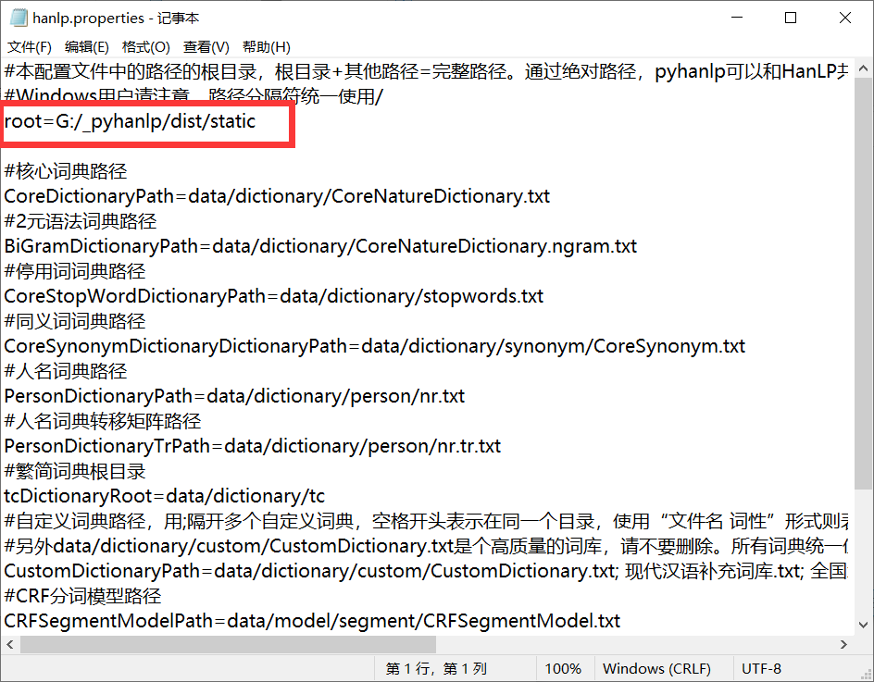

Figure 5: "root = g:/\_ Pyhanlp / dist / static "

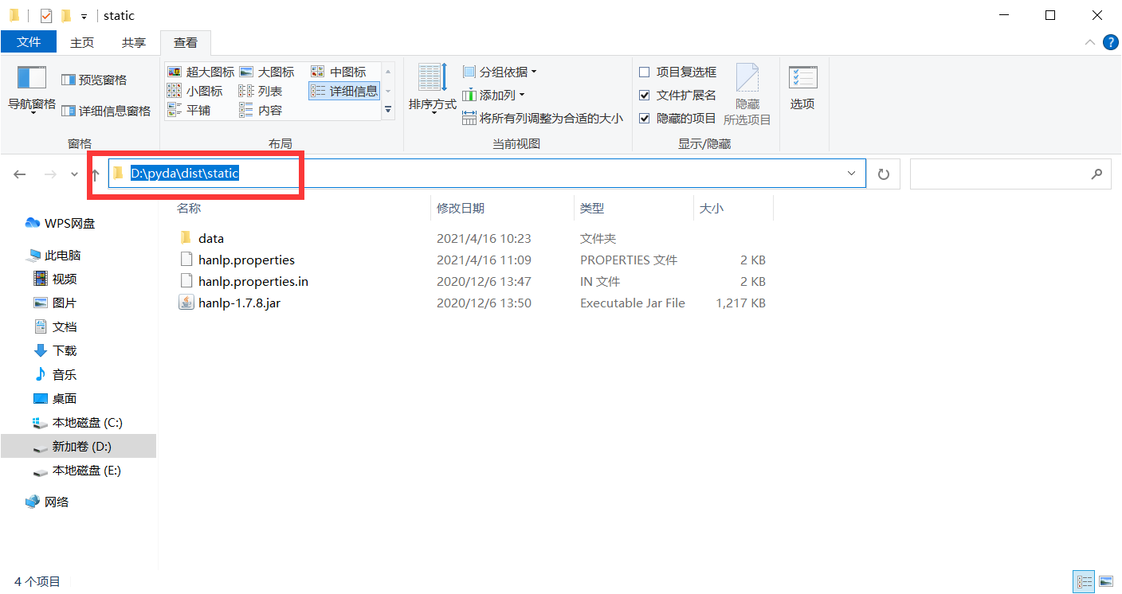

Figure 6: The current path of the file "hanlp.properties"

Please note that you do not copy and paste this path directly. You need to use '/' to modify the path separator.

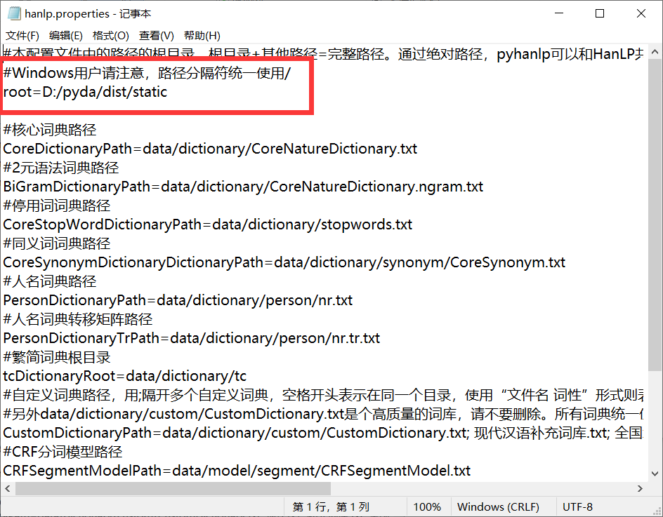

Figure 7: The path to the completion of file modification

**Step 4 :** go back to the folder "dist", find the file "GUI.exe", double-click to open it, as shown in Figure 8 and Figure 9.

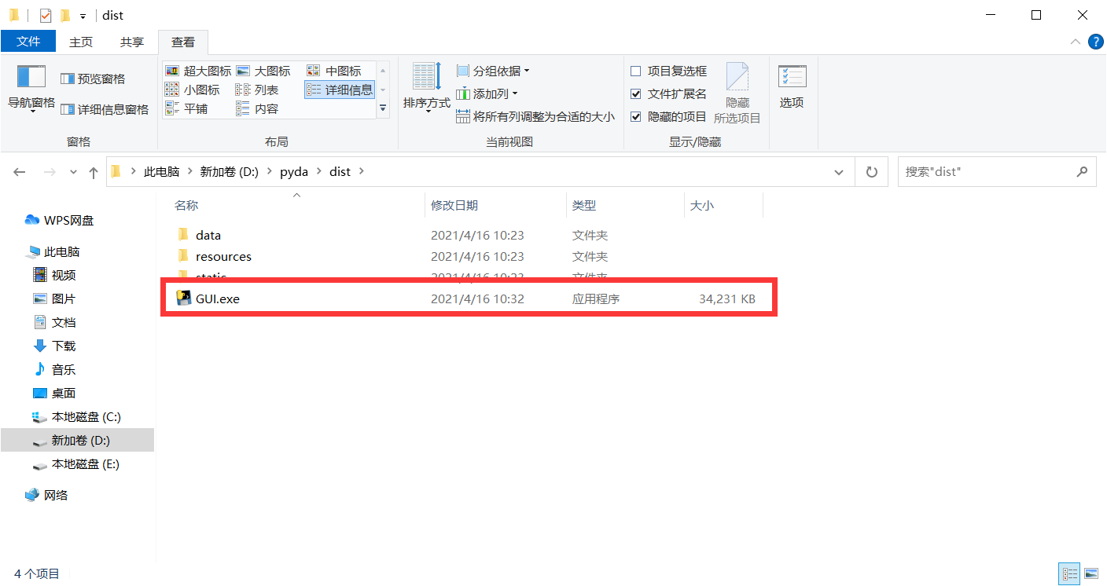

Figure 8: The file "GUI.exe"

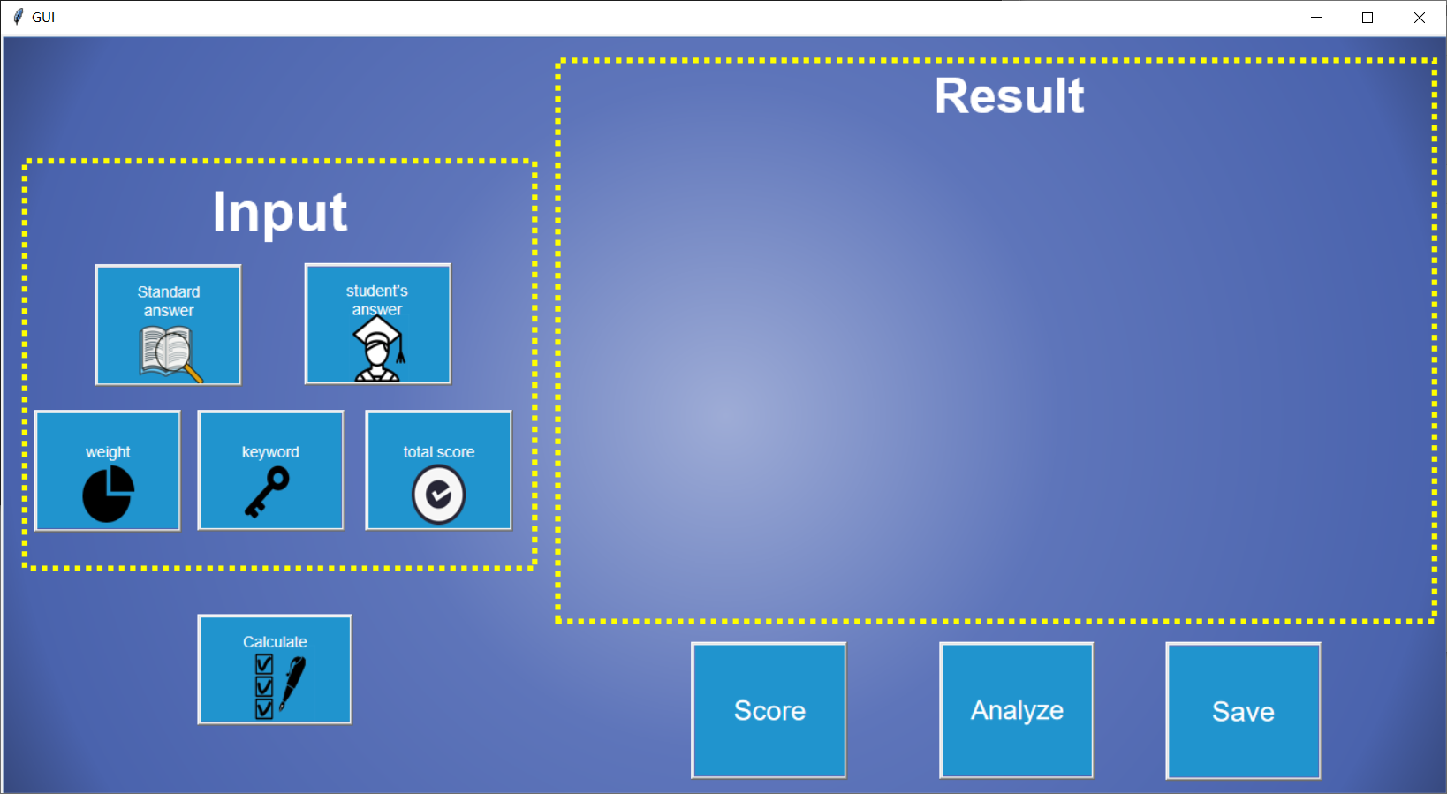

Figure 9: Visual interface GUI

## Part Two: Common installation errors of GUI

## **Case 1**

## IMG_256

Figure 10: Case 1

**Error reason:** Chinese appears in the path.

**Solution:** put the extracted file in a pure English path.

## **Case 2**

## IMG_256

Figure 11: Case 1

**Error reason:** the path divider is "\".

**Solution:** change the path divider to "/"